Tickets Make Great Gifts
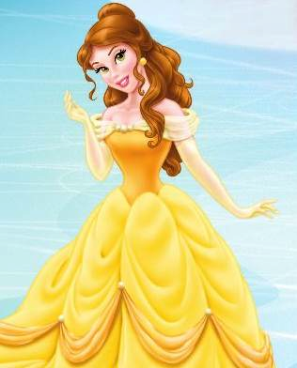

Make Belle’s Ticket Rose Bouquet!

What You Need:

• Disney On Ice presents Rockin’ Ever After tickets
• Pencils or wire
• Floral tape
• Ribbon
• Optional Disney On Ice gift tag
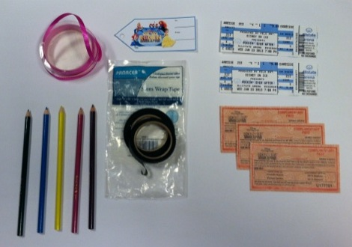

Directions:

1. Roll your ticket around the end of the
pencil in a cone-‐like way

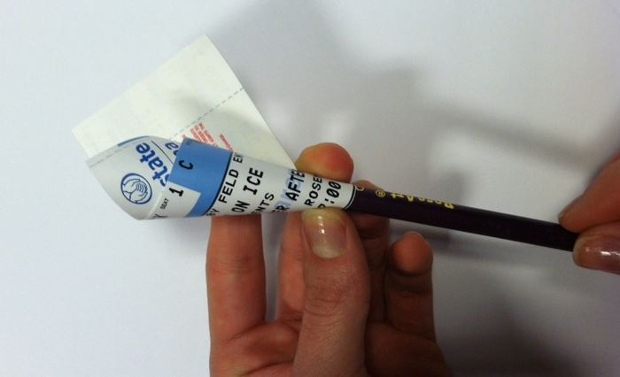

3. Work your way down the pencil or wire with the floral tape, wrapping it diagonally on the pencil or wire.

2. Using the floral tape, start taping the base of the ticket to the pencil, securing the ticket in place.

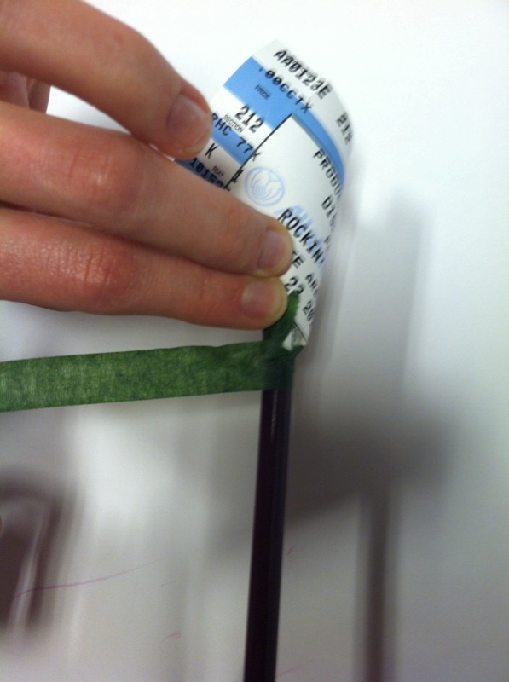
4. Bundle your “roses” into a bouquet and tie them together with a piece of
ribbon. Bonus – Add a Disney On Ice gift
tag for extra fun!

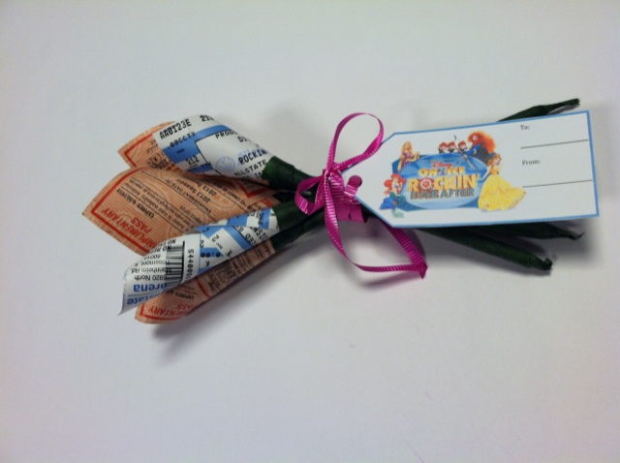

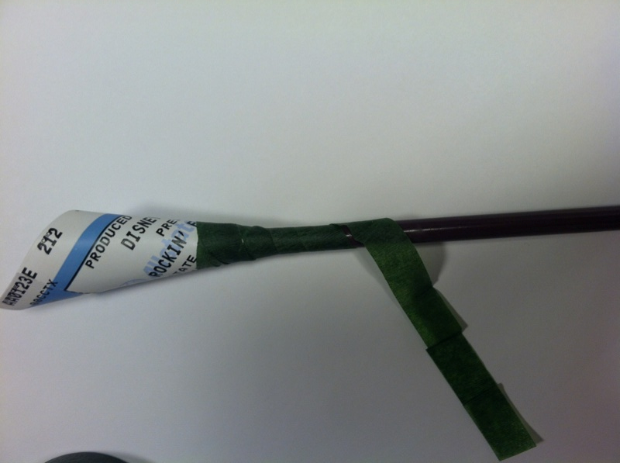

Tickets Make Great Gifts
Now you have a bouquet of roses like Belle from Beauty and the Beast as a way to give your
children tickets to Disney On Ice presents Rockin’ Ever After!
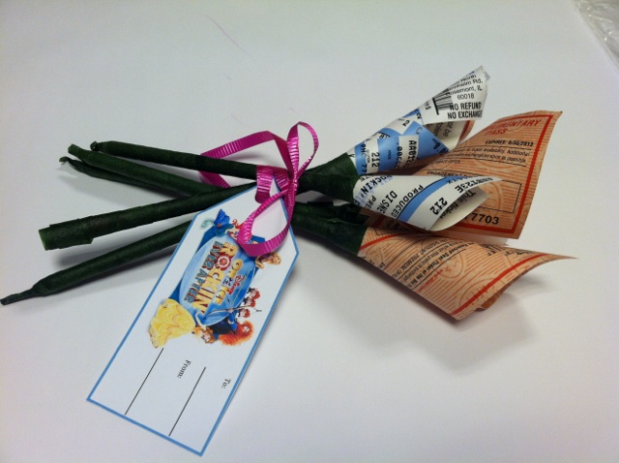

Bonus Tips:

1. You might find it easier to roll the ticket into a cone like shape before you put it on the pencil or wire, rather than roll it around the pencil or wire.

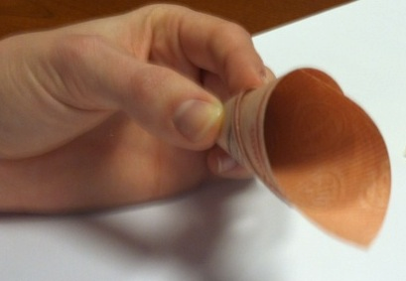

2. If you use wire, you just have to tape the wire inside the ticket, no need to wrap it.

3. The floral tape won’t damage the tickets and comes off easy, so it’s perfect for this craft.

